FOR IMMEDIATE RELEASE
FEBRUARY 21, 2024
Contact:
Holden Armstrong, NDVA Communications Director
402-219-1704, holden.armstrong@nebraska.gov
NDVA Wins VA Pillars of Excellence Award for Veterans Mission of Mercy Dental Clinic
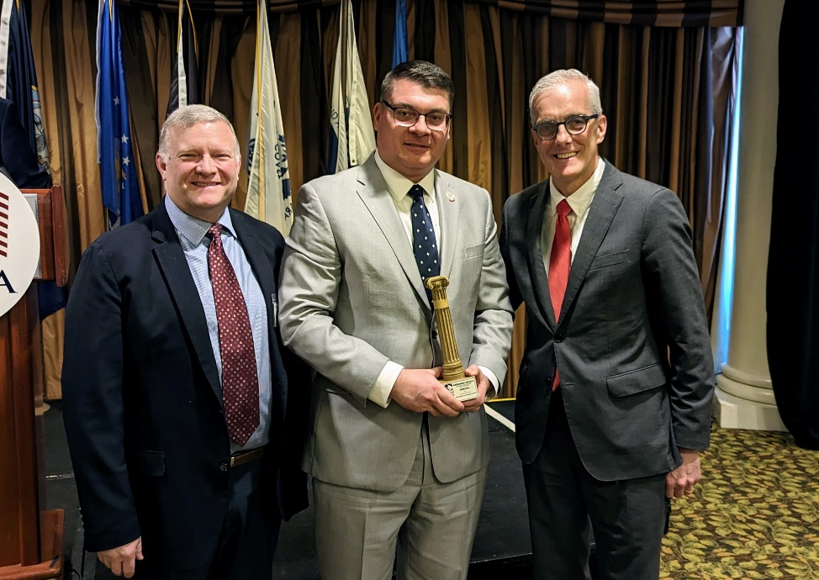
From left to right, NASDVA President Dennis Wimer, NDVA Director John Hilgert, and VA Secretary Denis McDonough at the Abraham Lincoln Pillars of Excellence Award ceremony. Additional photos from the award presentation and dental clinic are available here.
WASHINGTON (FEB 21, 2024) — On Wednesday, U.S. Department of Veterans Affairs (VA) Secretary Denis McDonough presented the Nebraska Department of Veterans’ Affairs (NDVA) with an Abraham Lincoln Pillars of Excellence Award in recognition of the Veterans Mission of Mercy Dental Clinic, held in October 2023.
“It’s an honor to receive a Pillars of Excellence award two years in a row, and it speaks to the efforts NDVA is making to serve veterans and their families through innovative initiatives,” said NDVA Director John Hilgert. “The dental clinic is a great example of how we do things in Nebraska because it was a close collaboration between several organizations, all of which recognized an unmet need in our state and offered their specific resources and expertise to help meet that need.”
Hundreds of volunteers from dozens of organizations helped conduct the clinic which provided 309 individuals, including 225 veterans and 84 spouses and surviving spouses of veterans, with free dental care. Services included exams, cleanings, fillings, root canals, extractions, and more. Sixty individuals received dentures over the course of the clinic, thanks to technology that allowed for intraoral scanning and 3D printing of dentures that could be picked up the same day or the next.
The value of care provided at the clinic, based on equivalent Medicaid/Medicare reimbursements, totaled $406,512. In total, 2,323 dental services were provided, with most participants receiving multiple services. One participant remarked the estimate he’d received for all the work he needed exceeded $30,000, and thanks to the clinic, most of that work had been done at no cost.
“Veterans are one of the largest underserved dental populations in Nebraska,” said State Dental Health Director Dr. Charles F. Craft. “By pooling our professional resources together, with the assets of the NDVA and the NE National Guard, we were able to conduct a humanitarian mission that helped address the oral health care needs of many veterans. The success of this first-time event demonstrated the pride Nebraska has for its military members. It was an honor to serve those who served our country.”
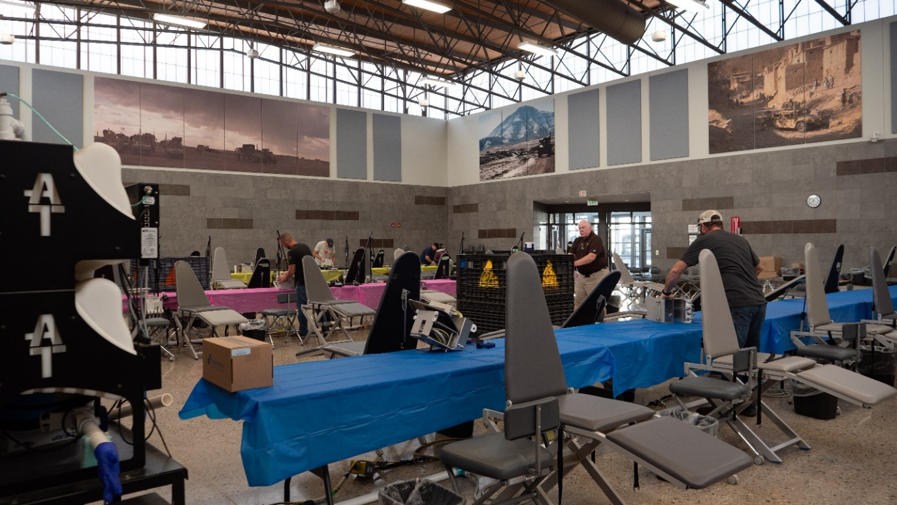
Volunteers transform the Titan Readiness Center’s gym into a state-of-the-art dental clinic.
The clinic was a partnership between NDVA, DHHS Office of Oral Health and Dentistry, Nebraska Dental Foundation (NDF), University of Nebraska Medical Center (UNMC) College of Dentistry, Creighton University School of Dentistry, and the Nebraska National Guard (NENG).
“The Veterans Mission of Mercy dental clinic was a wonderful collaboration of organized dentistry, Nebraska Office of Oral Health, NDVA, and the Nebraska National Guard to provide much-needed oral health care to Nebraska veterans and their spouses,” said NDF President David O’Doherty.
NDF funded the clinic, utilizing the American Dentists Care Foundation’s national “Mission of Mercy” program to rent or purchase most of the equipment and supplies. Local organizations provided specialty equipment, such as the intraoral scanners and 3D printers from Dental Design Lab in Lincoln and Fuhrman Dental Lab in Norfolk, X-ray equipment from Dexis Imaging and Ponca Health Services, and wi-fi through the Farm Bureau.
“The Nebraska Veterans Mission of Mercy 2023 was a wonderful event to help our veterans in need,” said Dr. Jim Jenkins of the UNMC College of Dentistry. “It was an incredible group effort between health groups, dental schools, and the National Guard to make it happen; and the cooperation was amazing. I was very pleased with the success of the event, and all the volunteers did a wonderful job to help our veterans with their dental needs. The UNMC College of Dentistry students and faculty who volunteered their time and talents for the veterans’ clinic had a fantastic experience.”
Dentures being produced for a veteran whose mouth was scanned using a CEREC intraoral scanner earlier in the day.
The clinic was staffed primarily by volunteers, including 274 dentists, dental students, dental hygienists, and dental hygiene students and numerous non-dental volunteers who helped with setup, check-in, and other non-clinical tasks. Most volunteers came from the UNMC College of Dentistry and Creighton University School of Dentistry, with others coming from private offices, dental companies, the Nebraska Dental Hygiene Association, Southeast Community College Dental Assistant program, and UNL Pre-Dental Club. NDVA public servants, county veteran service officers, VA employees, and others were also on-hand to provide non-clinical, veteran support.
“It was an honor and privilege for the Creighton University School of Dentistry to participate in this worthwhile endeavor serving our Nebraska veterans and their spouses,” said Dr. Joe Franco of the Creighton Dental School. “This event epitomizes Creighton’s commitment to the community for both our students and faculty. Both our students and faculty enjoyed the positive experience and satisfaction providing a wide range of dental care to our veterans. Creighton School of Dentistry is looking forward to participating and collaborating with the Nebraska Department of Veterans’ Affairs in future events.”
The Nebraska National Guard allowed for the use of the Titan Readiness Center in Yutan, Neb., with the large gym serving as the main work area and smaller rooms providing space for intake and triage, X-rays, 3D scanning and printing for dentures, patient recovery, and a veterans claims filing area with accredited veteran service officers. Vet Center staff members were on hand to offer additional resources to attendees, and the “Remembering Our Fallen” memorial, a traveling exhibit that honors the Nebraskans who have been killed during the Global War on Terrorism since 9/11, was on display.
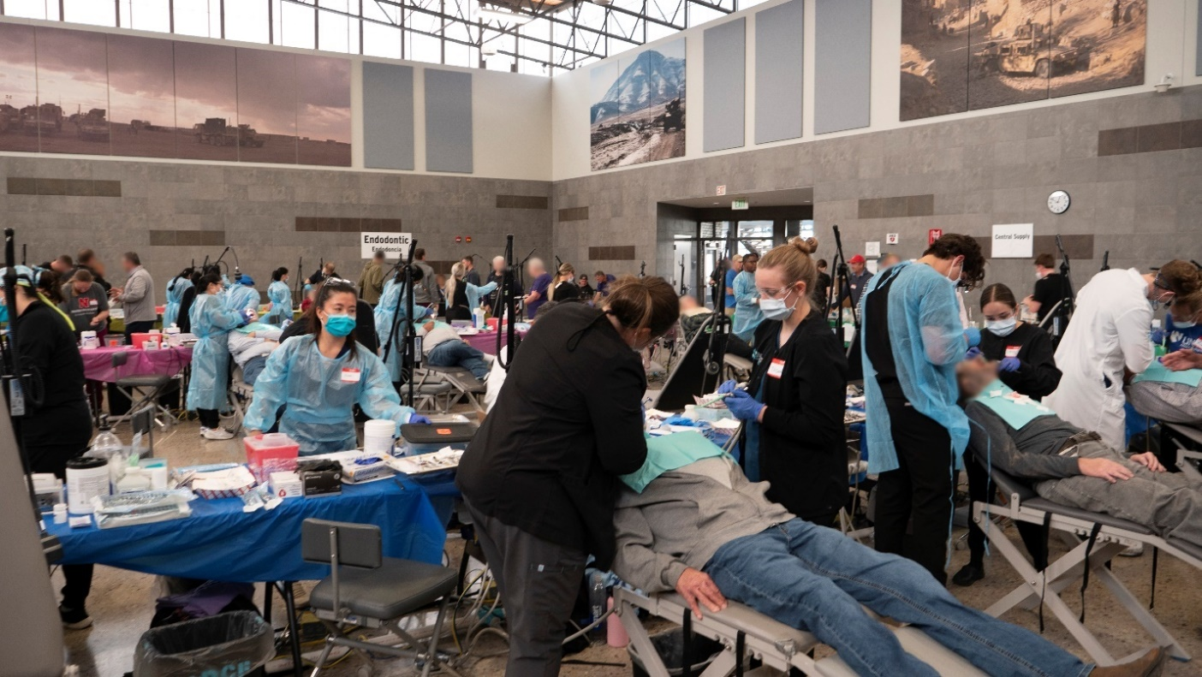Dentists, dental students, dental hygienists, and dental hygiene students provide care to veterans and their spouses at the Veterans Mission of Mercy Dental Clinic.
“This was a remarkable coalition of skilled and dedicated people coming together to help Nebraska veterans, and the Nebraska National Guard was proud to partner with Nebraska Department of Veterans’ Affairs in such an impactful effort,” said Maj. Scott Ingalsbe, Nebraska National Guard state public affairs officer. “On a rare weekend where the Titan Readiness Center was not being used for National Guard units’ training, we were glad to make it available to an all-volunteer army of dental care providers taking care of veterans in need.”
Participants traveled to the clinic from nearly 50 counties across the state, with over 15% of patients traveling over 100 miles to attend and 9% traveling over 250 miles. Individuals who were identified as needing additional dental services were provided with information for assistance through Nebraska Veterans Aid, their local County Veterans Service Officer, or alternative/low-cost dental services.
Based on the success of the event, NDVA and other partners involved hope to host another Veterans Mission of Mercy clinic in the fall of 2024. To stay up to date on this potential event and others, interested parties can sign up to receive emails from NDVA at veterans.nebraska.gov/subscribe.
The Abraham Lincoln Pillars of Excellence Award is a recognition program developed by the VA Office of Intergovernmental Affairs and the National Association of State Directors of Veterans Affairs (NASDVA). The award allows VA and NASDVA to evaluate state and territory programs to establish best practices and provide a model for other states and territories to implement programs that benefit veterans and their families across the Nation. Award categories include customer experience with VA benefits and services, eliminating veteran homelessness, suicide awareness and prevention, delivery of services to tribal governments serving Native American Veterans, innovative state programs, and eliminating the claims and appeals backlog. Nebraska was among seven states and territories to be recognized with a Pillars of Excellence award this year at the NASDVA Midwinter Training Conference in Washington, D.C.
###

